Confirmation email:

- Please remove the alternate language link as this is no longer applicable.
- Please separate the {CustomerServicesURL} from the {CustomerServicesEmailAddress}, see UA example.
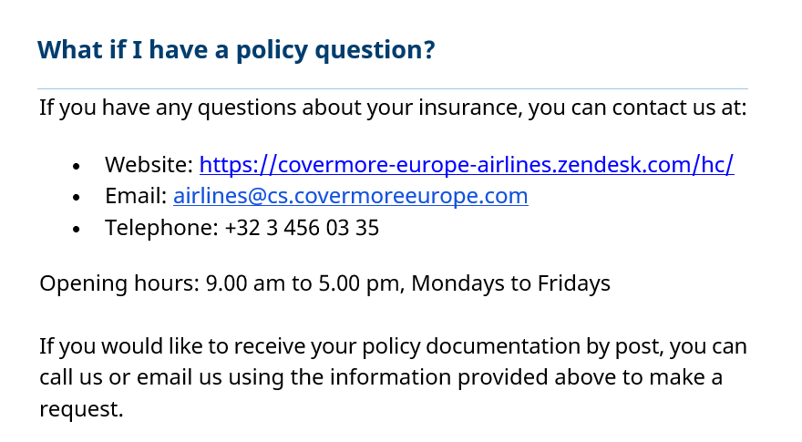

English | If you have any questions about your insurance, you can contact us at:  - Website: {{CustomerServicesURL}}  - Email: {{CustomerServicesEmail}}  - Telephone: {{CustomerServicesNumber}}  Opening hours: {{CustomerServicesOpeningHours}}  If you would like to receive your policy documentation by post, you can call us or email us using the information provided above to make a request.
Swedish | Om du har några frågor om din försäkring kan du kontakta oss på:  - Webbplats: {{{{CustomerServicesURL}}  - E-post: {{ CustomerServicesEmail }}  - Telefon: {{CustomerServicesNumber}} (MVS)  Öppettider: {{CustomerServicesOpeningHoursLocal}}  Om du vill få din försäkringsdokumentation via post kan du ringa oss eller mejla oss med hjälp av informationen ovan för att göra en begäran.

